Dear Koinonia Supporter,

Thank you very much for your consideration and generous donations to support the 2017 summer enrichment program provided by Koinonia of Columbia.

We respectfully request your consideration of a donation of $100 or $250 or any amount that God leads you to give to complete the 2017 Summer Enrichment Program. Kelly and I are committed to this program and future projects, and will match any donation received from June 15 to July 15 up to a total of $5,000 in donation matches.

**How to donate:** Either donate directly on our website at [www.koinoniaofcolumbia.org](http://www.koinoniaofcolumbia.org)

Or, you can send a check payable to Koinonia of Columbia Inc.; PO Box 30518; Columbia, SC 29230.

With our excellent staff and team of volunteers, our children receive safe, quality, loving education, meals and play. Please see our Facebook posts of the program at [www.facebook.com/EauClaire2017](http://www.facebook.com/EauClaire2017).

The second page of this letter includes a summary of the achievements and partnerships that this first program has helped to create.

**2017 Summer Enrichment Forecast Cost:**

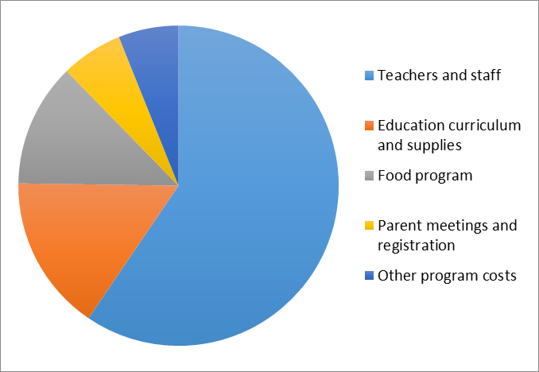

**Achievements as of June 12, 2017:**

* Koinonia of Columbia Inc. has received tax exempt status 501c (3) from the IRS effective retroactively to March 9, 2017 (date of incorporation).
* Partnership with Eau Claire Baptist Church provides the student facility without rent or other facility costs
* Partnership grant for $3,000 from the South Carolina Cooperative Baptist Fellowship
* Grant and total donations received of $17,260 from 31 individual donors
* An average daily attendance between 50-60 children
* Active commitment from volunteers, teachers, student teacher interns and helpers
* Additional information is available at the Koinonia of Columbia website [www.koinoniaofcolumbia.org](http://www.koinoniaofcolumbia.org)

Thank you again for your generosity and commitment to invest in the children and youth of our community.

Sincerely,

David M. Strum, Treasurer