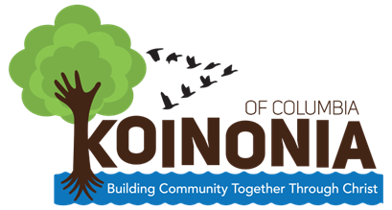

SUMMER CAMP, 2018

Where: Eau Claire Baptist Church
4427 North main Street
Columbia, SC 29203
803-786-7769

When: Tuesday, June 12-Friday, August 3, 2018
Daily from 9:00-5:00 (Closed July 2-6)

Who: Rising first through Rising 5th Grade Students
(Students in K-4th in the 2017-18 School Year)
Serving Students in the eau Claire Community
No more than 60 students – first come, first served

All students will receive reading, Writing and Math Instruction with certified teachers and will participate in enrichment activities in Art, Music, Physical Education, Bible study and Character Education. Lunch will be provided and limited transportation is available.

To be considered for this program, please complete this form and mail it to the church, ATTN: Koinonia, or email the form to redwardmoore4@gmail.com or you may complete the form online at www.koinoniaofcolumbia.org.
You will be contacted about parent meetings and/or appointments to complete application forms as space is available.

Questions/Concerns: Contact Richard Moore, Director
803-920-1530 or redwardmoore4@gmail.com
Yes, I am interested in having my children attend the Koinonia Summer Camp at Eau Claire Baptist Church.

Name:___________________________________Phone:_________________________________*

Name(s) and Grade(s) of Child(ren):

__________________________ ______ ________________________ _____

__________________________ ______ ________________________ _____

__________________________ ______ ________________________ _____

*In order for you to be considered, we must have a working phone number where you can be reached. Forms with non-working numbers will not be processed.

